How to Search the Official Record for Final Judgments for Injunction for the Protection of a Minor

- Click the link on the homepage to search for Final Judgments for Injunction for the Protection of a Minor, as shown below (image is a placeholder example screenshot from Alachua of what the link/button should look like on the homepage):
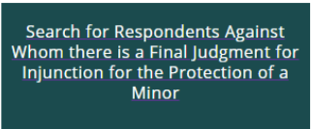

or click the Official Records link in the ribbon, as shown below: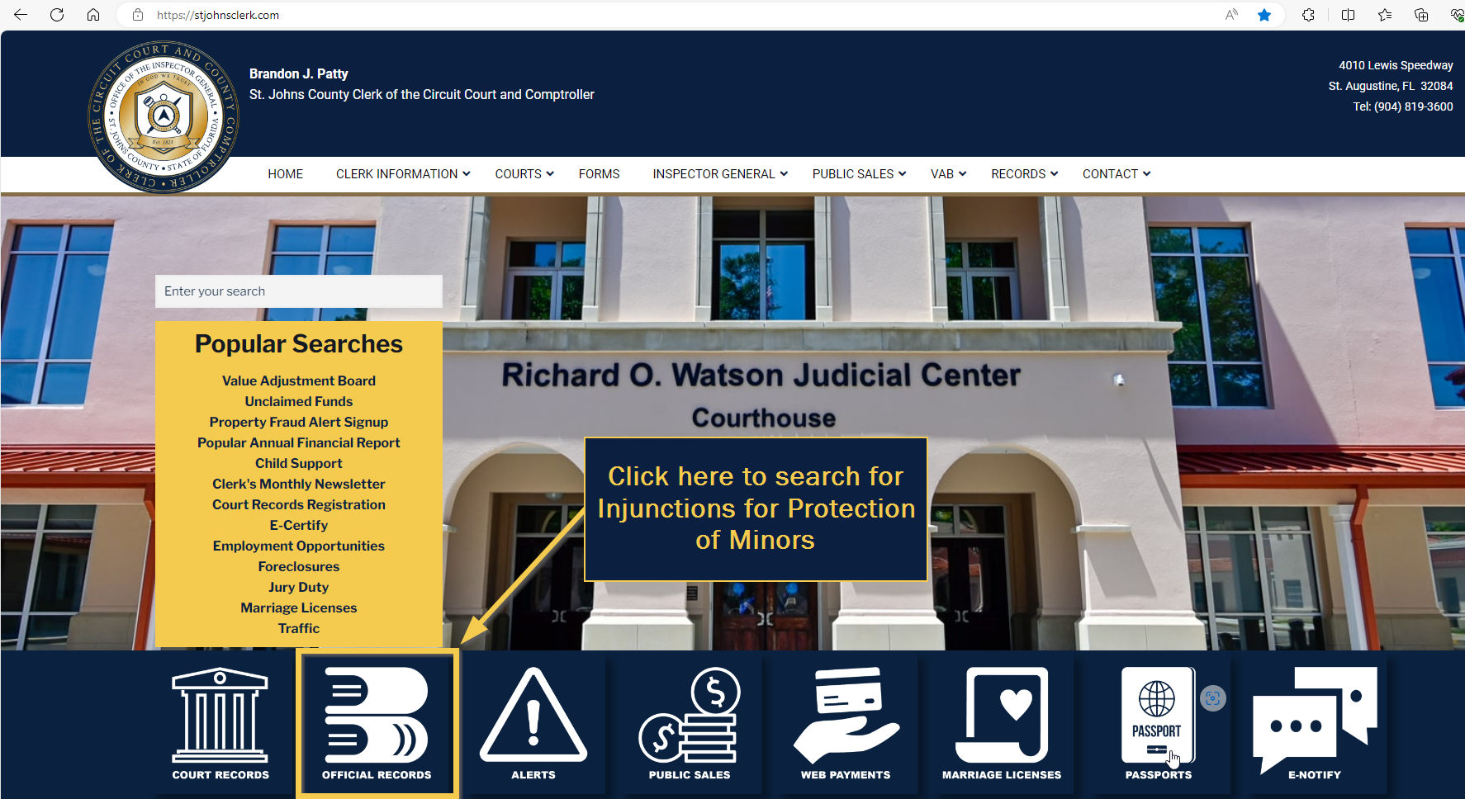

- To search by the respondent’s name (i.e., the name of the person whom the injunction is against), click the name icon (1):
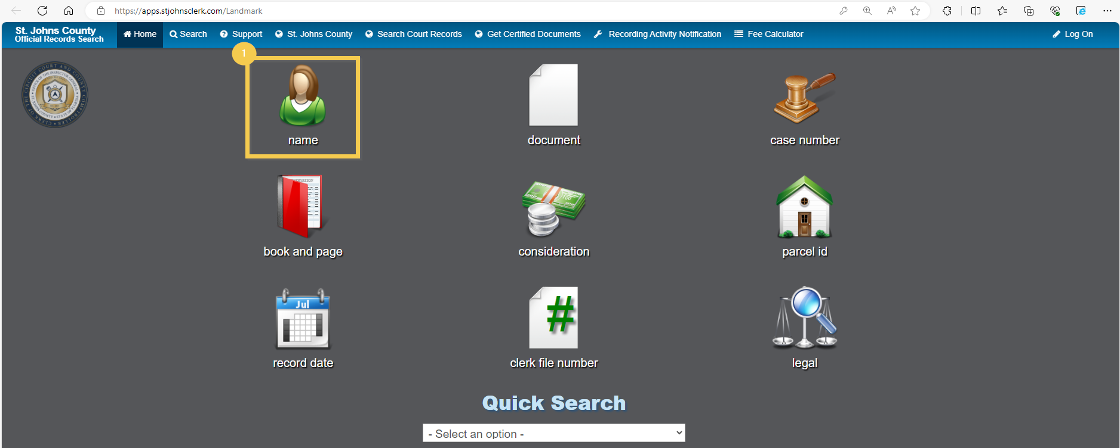

- Accept (1) the Disclaimer popup to continue your search.
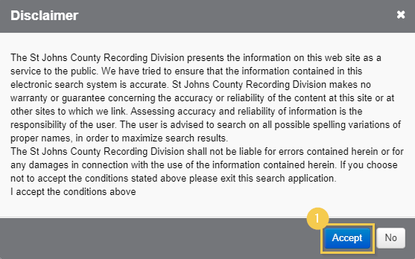

- Our office recommends changing the search parameters to Contains to ensure a matching record is found.

To do so, change the Name field dropdown to Contains (1):
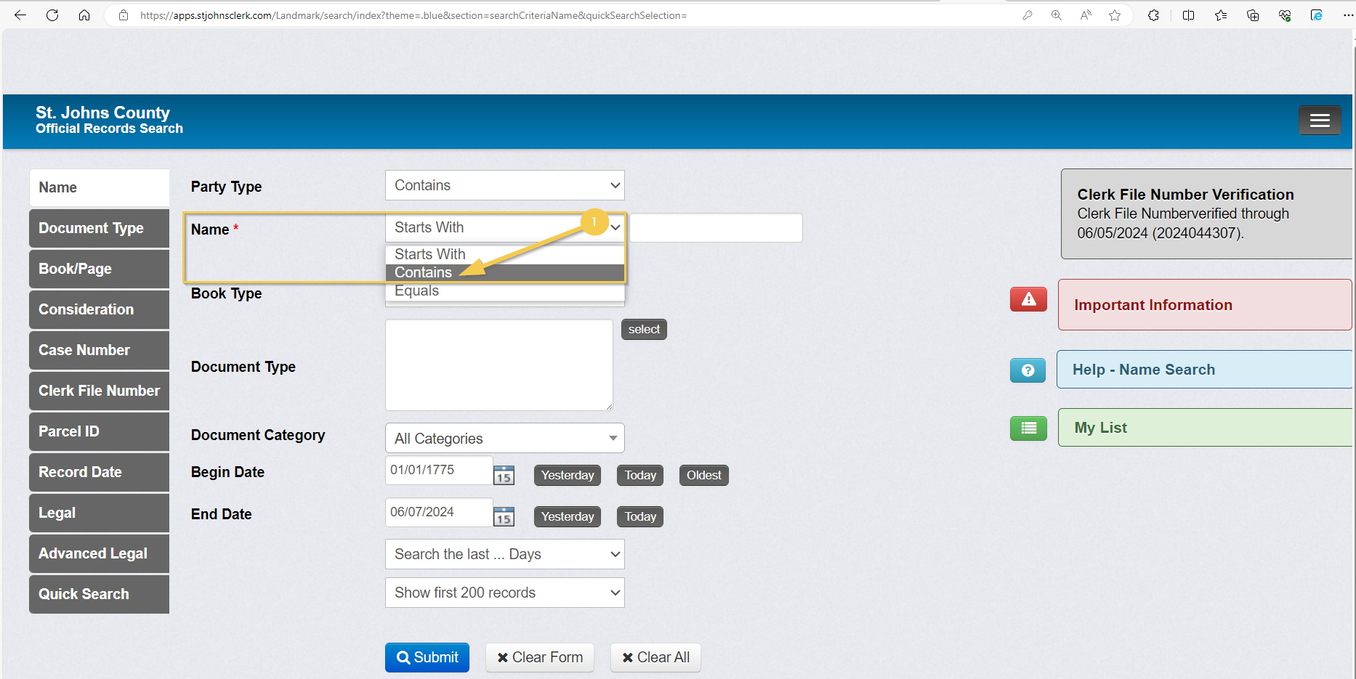

- Enter the respondent’s name into the Name field (1):
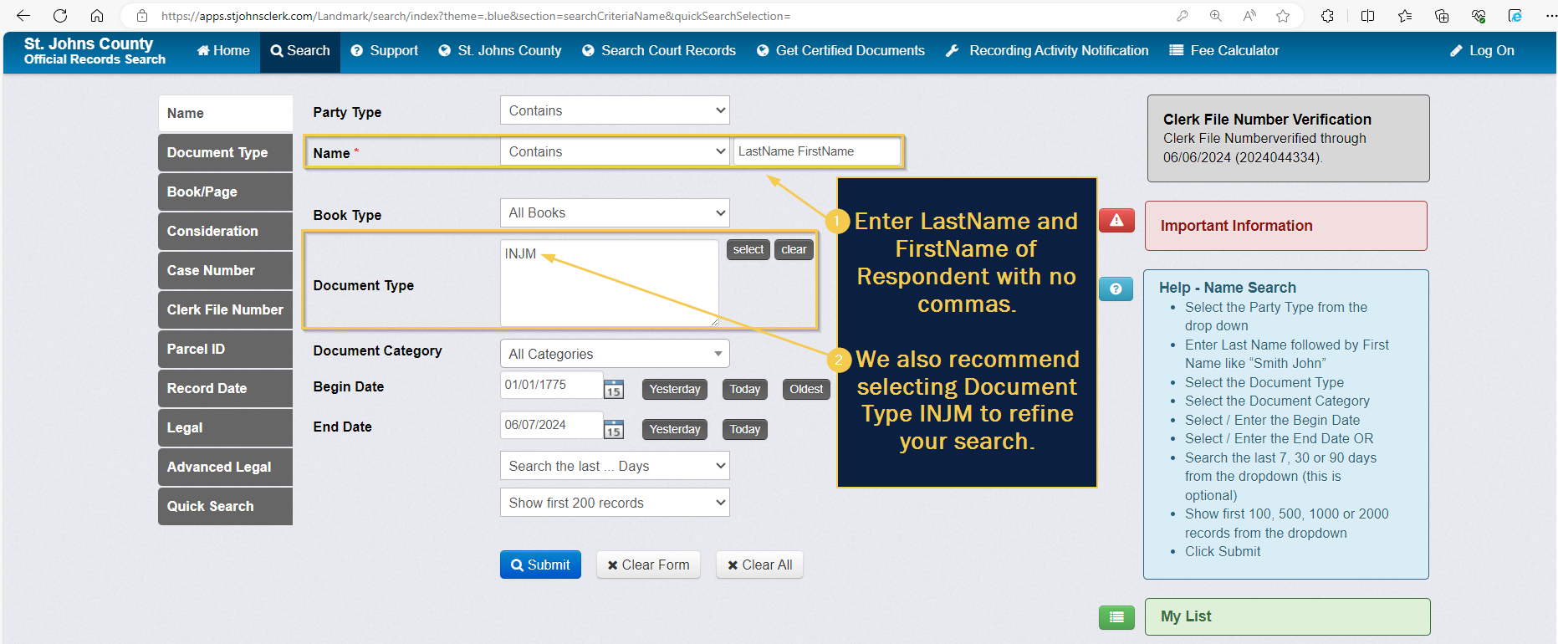

- The results will appear as shown below, and the respondent’s identity (i.e., name) will be viewable in the Reverse Name column of the search results.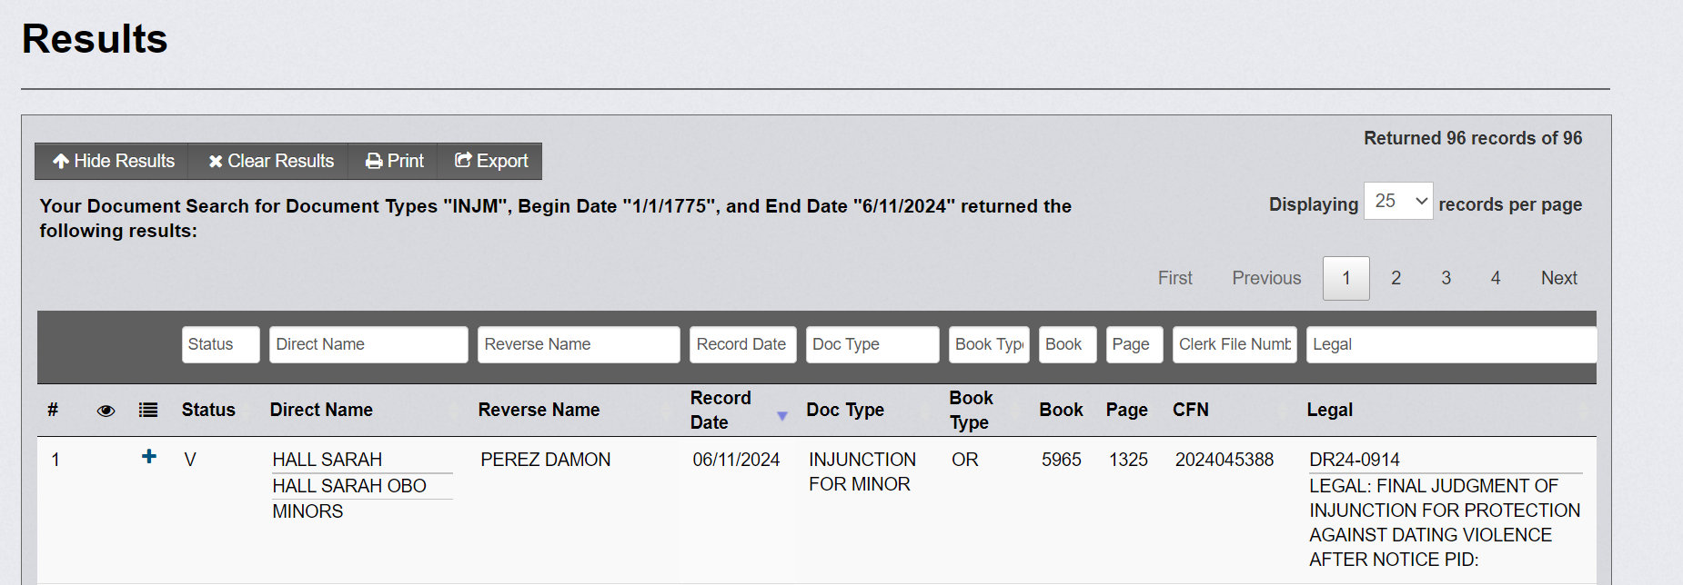

Secondary/Optional Search Method
You may search by selecting only the INJM Document Type described in Step 5 above if you do not know the name of the respondent or are interested in researching all recorded Final Judgments for Injunction for Protection of a Minor in St. Johns County.
- To search for all recorded Final Judgments for Injunction for Protection of a Minor, begin a document type (1) search and accept the Disclaimer.
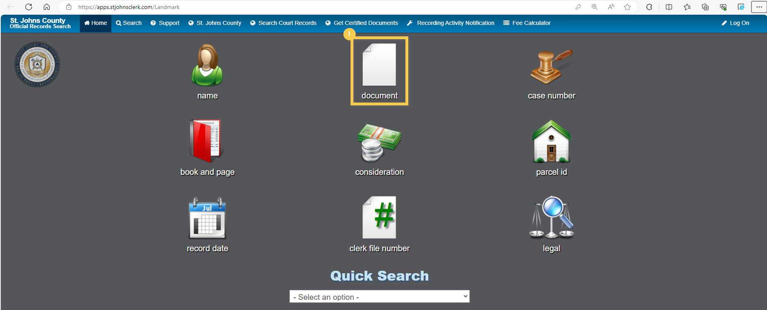
Note: The Final Judgment for Injunction for Protection of a Minor images are not viewable through a publicly available Internet website for general public display (see §28.2221(5)(a), only the identity (i.e., name) of the respondent is available as required by §28.2221(8)(a).

- Click select as shown below to search by the Document Type code:
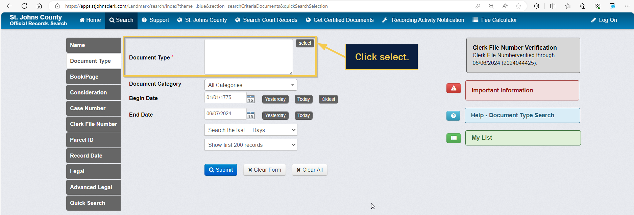

- Click the INJUNCTION FOR MINOR document type.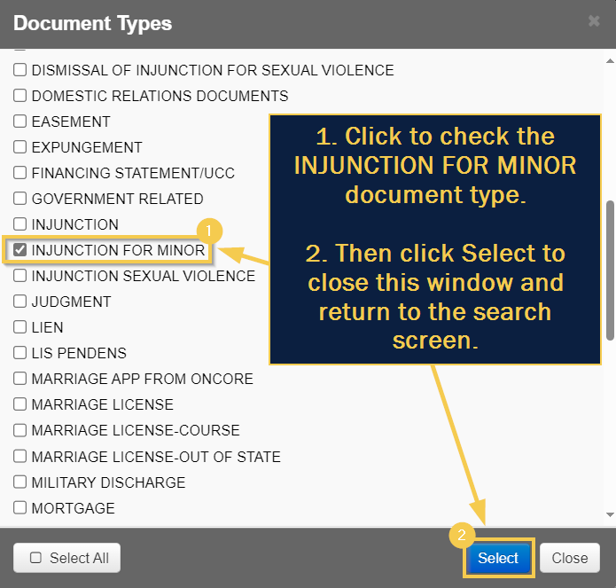

- Click Submit (2) to perform the search.
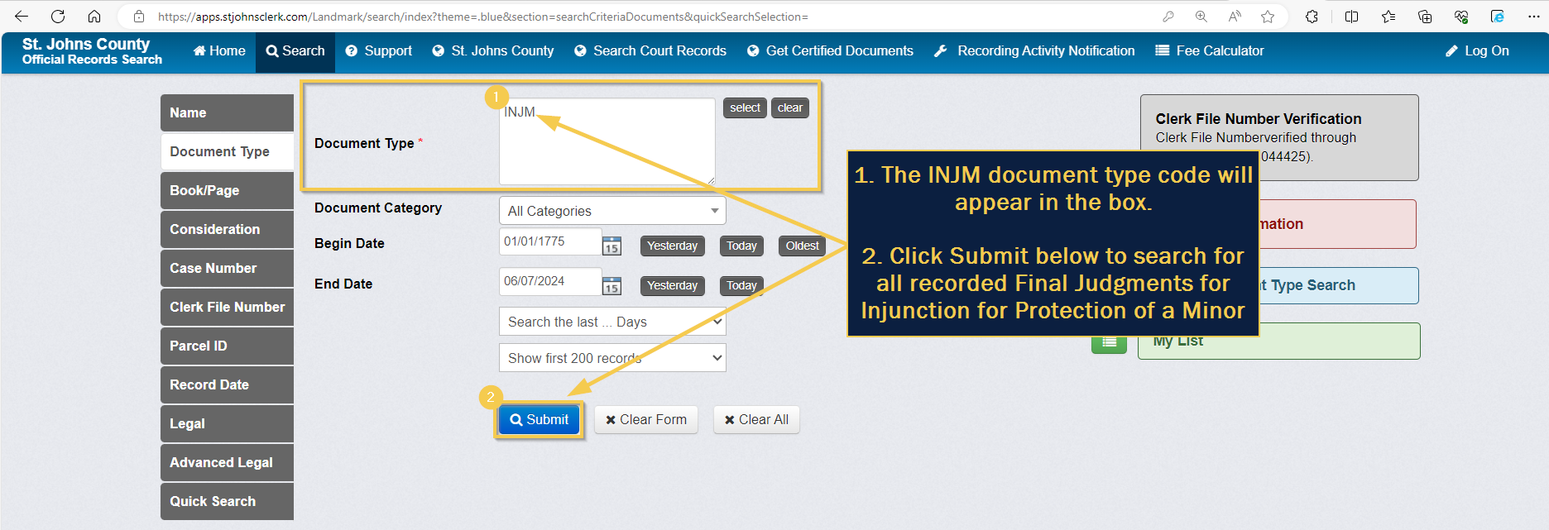

- The results will appear as shown below, and respondent identities (i.e., names) will be viewable in the Reverse Name column of the search results.

